Food, Fellowship, and Faith for Adults

Monday, May 20th

“What I Have Learned From the Game of Golf”
Father Jeremy Merzweiler Our Lady of the Cedars
Pastor 507 S Cleveland Massillon Rd
St. Francis de Sales Parish, Akron Fairlawn, OH 44333

Doors open 7:00 pm, Speaker 7:30 pm
$15.00 Admission includes light appetizers. Cash bar available.
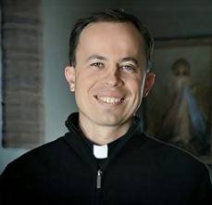
Sponsored by:
St. Sebastian Parish
Akron
TheologyontheRocks

TheologyontheRocks

