Office use only: MC: Y N
Cash Check #______
Date:_____ Amount:_____
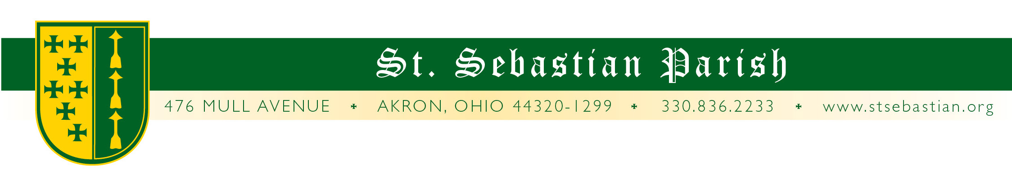
Parish School of Religion Registration Form
2024-2025
Please complete ALL sections
Father’s Name: | Father’s Religion:
Mother’s Name: Maiden: | Mother’s Religion:
Mailing address: | City ZIP
Cell Phone: Father | Cell Phone: Mother
Email: Father | Email: Mother
Parents are: ___Married___Sep/Divorced___Widowed___Single Parent | With whom does the child reside:
NEW REGISTRANTS: IF YOUR CHILD WAS NOT BAPTIZED AT ST. SEBASTIAN PLEASE PROVIDE A COPY OF THEIR BAPTISMAL CERTIFICATE TO REMAIN ON FILE IN OUR OFFICE.
***CHECK SACRAMENTS RECEIVED***
Child’s Name  (include last name if different) | Date of Birth | School Attending | Grade  (Fall 2024) | Baptism | Church of Baptism  (City, State) | Penance | First  Eucharist | Confirmation

See reverse side for consent, emergency, and fee information.

CONSENT FORM AND EMERGENCY INFORMATION
As the parent/guardian of the child(ren) named on the reverse side, permission is hereby given for my child(ren)to participate in the PSR Program, including Praesidium, and in any activities sponsored by St. Sebastian Parish in Akron, Ohio.
I recognize that engaging in the activities at St. Sebastian may expose my child to the possibility of physical injury, and I assume full responsibility for any of these risks. I hereby release St. Sebastian Parish, the Diocese of Cleveland and its Bishop, and their employees, organizers, subsidiaries, and any volunteers assisting in the program, from any and all liability and claims arising out of my child’s participation in programs and related activities.
In the event my child should require medical treatment, I also give permission for such medical treatment to be secured at my cost.
I recognize that my child’s participation in the activities of St. Sebastian Parish will be governed by such rules and regulations as established by the St. Sebastian PSR Program.
I understand that my child’s photograph may be taken during activities. Those photographs may be used on the parish website, in the parish bulletin, or parish social media as appropriate.

Signature:_____________________________________________________________________________ Date ________________________________________

EMERGENCY INFORMATION
Please list allergies or medical conditions for each child to be kept on record ____________________________________________________________________ ______________________________________________________________________________________________________________________________________________________________________________________________________________________________________________________________________
Please list the names of two people (friend or relative) who would assume custodial care in the event of an emergency if we are unable to reach you.

Name ____________________________________________________________________ Phone_________________________________________
Name ____________________________________________________________________ Phone_________________________________________
INSURANCE INFORMATION
Health Insurance Carrier________________________________________ Policy Number__________________________________________________
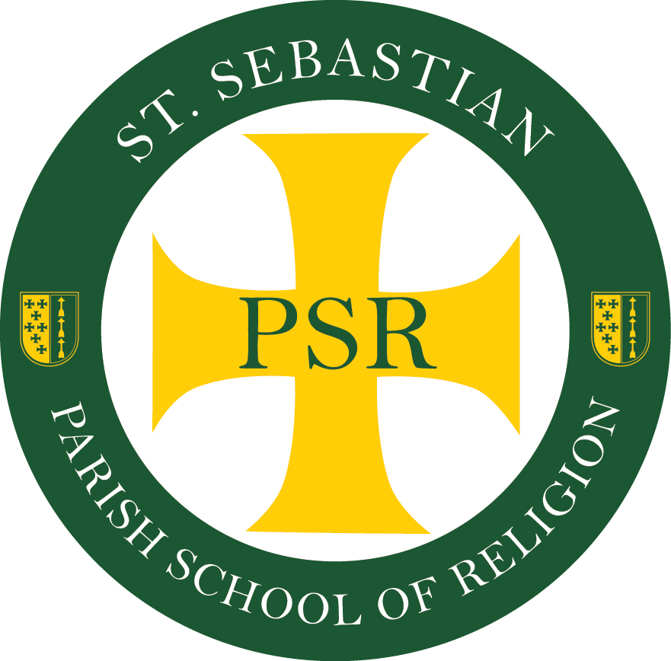
Information and Fees
- PSR Classes are held on Sunday mornings, from 9:30-10:45 in the St. Sebastian Parish School Building
- Fees are $55.00 for the first child; $40.00 for any additional children.
- Make all checks payable to “St. Sebastian Parish”

