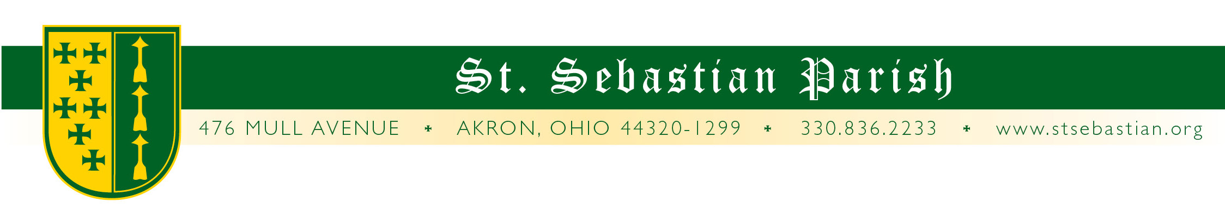

Angelus Letter
15 October 2020
Thursday of the Twenty-Eighth Week in Ordinary Time

Dear Parish Family,

WHAT YOU NEED TO KNOW FOR THIS WEEKEND

Friday Mass 8AM* Fr. Simone
Confessions 4 to 5PM*
Saturday Mass 8AM* Fr. Simone
Confessions 9:30 to 10AM*
Vigil Mass 4:30** Fr. Valencheck
Sunday Mass 9AM* † Fr. Simone
Mass 11AM* Fr. Valencheck
Mass 1PM* Fr. Paschal OSB

* Masks are required. The Summit County Health Department has asked me to remind everyone to please wear a mask.

**At the 4:30 Mass, with permission from the diocese, there is an absolute requirement for masks to be worn.

† There will be a rosary at 10AM from now through November 1st.

DEACON TERRY

I fully expected to be writing to you about how well our beloved Deacon Terry is doing, but he has had a few setbacks recently that have greatly changed his prognosis. It seemed every time a wave of difficulty hit him, he’d come out alright and anticipate setting sail again with hopes of, if not smooth sailing, at least a longer, successful voyage. But the day after Fr. Simone and I visited with him last week, he ended up in the hospital with complications and suffered a heart attack.

On Wednesday, Deacon Terry was sent home (to his daughter’s house) with hospice care. This would be an excellent time to keep him, as well as his family in your prayers. God bless you Deacon Terry!

GROUNDS CREW

Our awesome volunteer Grounds Crew has announced that the season is coming to an end and this coming Thursday and the following Saturday morning, they will be preparing all the flower beds for winter. They could surely use your help! Just come and find someone working on the flower beds and ask, “What can I do?”

GOOD SAMARITAN FOOD CENTER

The Good Samaritan Hunger Center is hosting their annual “Soup for the City” fundraiser virtually. From October 17th - 24th, you can donate to help the Good Samaritan Hunger Center continue their mission to feed the hungry in and around Akron. For information and registration visit soup2020.givesmart.com

PETER MAURIN CENTER

St. Sebastian Parish will be manning the kitchen and serving meals at The Peter Maurin Center this weekend for our community in need. Our parish provides the meal at the center the 3rd Sunday of each month. Thank you to the volunteers who continue to serve the less fortunate in our community. May God bless each of you and the work that you do.

SUNDAY 10AM ROSARY

Fr. Simone will be leading a rosary every Sunday at 10AM through November 1st. Even if you go to another Mass, please feel welcome and encouraged to come back for the rosary.

BISHOP MALESIC

I had a virtual meeting with Bishop Malesic and a dozen or so other people concerning the future of Catholic schools. During our introduction I said, “We are looking forward to you visiting.” He responded, “I already did! I visited your parish last Sunday but I didn’t stop in because there were so many people and I didn’t want to interrupt.” He was on his way back from somewhere else and stopped by to see where St. Sebastian Parish was. I told him to come back some time and stay for a while!

NEXT SUNDAY

Next Sunday is priesthood Sunday as part of our annual celebration we will have a seminarian speak at all of the Masses. This year we will have Mr. Erin McGue! Some of you may know him from serving and lectoring at St. Sebastian, and belonging to last year’s Exodus 90 men’s group.

PRAYERS FOR THE SICK

Please keep all of our sick and distressed in your prayers:

The Caufield Family, Regina Buhalak, Rita Buhalak, Emilio Cheuy, Barbara Crawford, Rita Cummings, Anthony D’Attoma, Carolyn Jeske, Kimberly Jesser, Kathy Johnson, Chuck Kastor, Stan Kennedy, Jean Labate, Don Matis, Betty O’Hara. Pamela Oliver, Terry Peacock, Keith Pecek, Sue Prexta, Logan Rice, Frank and Nancy Ropchock, Nancy Rosche, John Schultz, Cory Schulz, Marilyn Spallino and Marie White.

God bless you,

Fr. Valencheck.
St. Sebastian, pray for us
.St. Mary, pray for us.
St. Teresa, pray for us.

