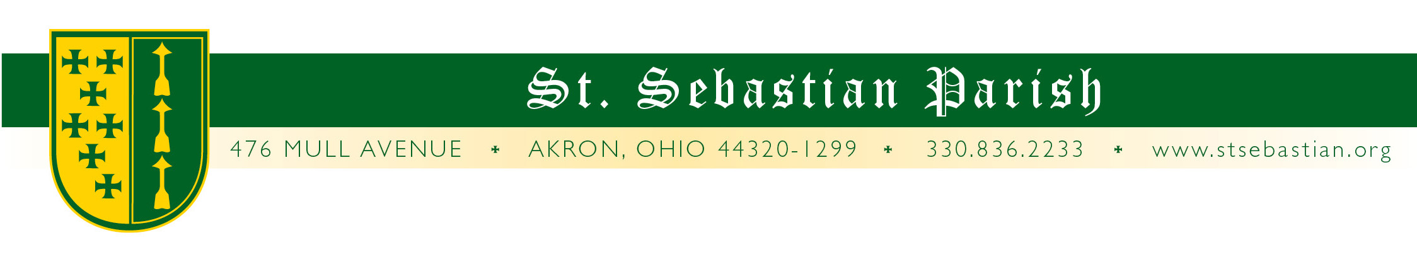
Angelus Letter
19 June 2020
Friday of the Eleventh Week in Ordinary Time
FEAST OF THE SACRED HEART OF JESUS

Dear Parish Family,

The Feast of the Sacred Heart is really a study on God’s love for us. In John’s first letter from Mass today he tells us, “Love one another because love is of God. Whoever is without love does not know God for God is love.” God is not a source of love but is Love Himself.

Jokingly you may have heard someone say, “I love humanity. It’s people I can’t stand.” The idea of loving humanity is an easy concept perhaps. It is when we get into the nitty gritty of individuals and situations that love becomes more tricky. Yet that is exactly where we are called to love. We are not to love (or hate) groups of people but to take each person as the sovereign individual that they are and to love them in their uniqueness.

One of the worst offenses against showing God’s love is putting seemingly all one kind of people in one pot and loving or hating them because of their group identity. It matters not if it is a race or skin color, or other category such as priests or police or politicians or beggars. No group - not even members of a family, can be labeled as, “They are all . . .”

The love of God impels us to love and to love each person as an individual sovereign person, which is the same way in which each of us is loved by God.

WHAT YOU NEED TO KNOW FOR THIS WEEKEND:

Corrected Sacramental Schedule:
Friday Confessions 4 to 5PM
Saturday Mass 8AM Fr. Simone
Confessions CANCELLED due to funeral.
1st Communion 11:00AM Fr. Valencheck
Vigil Mass 4:30PM Fr. Valencheck

Sunday Mass 9AM Fr. Valencheck
Mass* 11AM* Fr. Simone*
Mass 1PM Fr. Pfeiffer

*Mass is outdoors in the school courtyard weather permitting. Bring a lawn chair.

Special Notes for This Weekend:

Sign up for Eucharistic Devotions: Starting this weekend we will be asking for persons to sign up for a holy hour with the hope of restarting Adoration again not this Tuesday but Tuesday, June 30th, from after the 8AM Mass until 8PM in the evening. It may be that, due to the COVID threat, that we may still not have enough adorers to adequately staff each hour. That is fine. Please do not feel compelled to sign up for an hour if you are being cautious about your health. We will simply wait until there are enough adorers to cover all of the adoration hours (especially those pesky dinner time hours).

This Tuesday, however, we will keep with the COVID schedule of Exposition, Adoration, Compline and Benediction from 7PM to 8PM.

No Confessions Saturday Morning: Due to the celebration of a First Communion Mass and a funeral, there will not be confessions this Saturday morning, June 20th.

Outdoor Mass: The 11:00AM Mass will once again be out of doors weather permitting. Remember to bring a chair. Please park in the brick parking lot.

Today is also the day that our youth group would have been leaving for their annual retreat at the University of Steubenville. Special prayers for a safe, healthy and prayer-filled summer are sent for those youth and adults planning to attend as well as all of our parish young people. Hopefully everything will be back on track next year!

HAPPY FATHER’S DAY

Hey dads and all you men who fill in as mentors out there - many blessing to you on this Father’s Day. Thank you for all that you do.

THANKS TO ALL OF THE SEMINARIANS!

ALL HANDS ON DECK: We still hadn’t received the “all clear” to bring back many of our ministers including servers which would have made our Corpus Christi processions last weekend difficult at best! But, thanks be to God, we had the seminarians who are staying at our parish as well as several seminarians who came in to help out (plus, because Marcy said she would make them a Sunday dinner). Thanks and prayers to:

Charles Bulger St. Mary, Avon
Kevin Cush St. Luke, Lakewood
John Desmarteau St. Columbkille, Parma
Michael Garvin St. Hilary, Fairlawn
James Parisi St. Hilary, Fairlawn
The seminarians in residence at St. Sebastian Parish:
Cameron Ferrell Ss. Peter and Paul, Doylestown
Joseph Truong Viet Ho St. Boniface, Cleveland
Ian Kelly St Charles Borromeo, Parma
And from our parish helping out:
Liam Eitman

Please keep them and all contemplating a Church vocation in your prayers. Also, thank you to everyone who helped out with all the “behind-the-scenes” work that needed to take place to make our celebration possible. Also, the altar frontal used that day is a recent donation to the parish. It was handmade and is probably almost a century old and still beautiful.

PORCH CONCERT

There will be a concert on the church plaza on Sunday, June 28th at 5PM. Bring chairs or a blanket, socially distance yourself and enjoy the outdoors and some music.

PRAYERS FOR THE SICK

Please keep all of our sick and distressed in your prayers:

Regina Buhlak, Elizabeth Clark, Rita Cummings, Anthony D’Attoma, Gretchen & Steve Golnar, Carolyn Jeske, Kimberly Jesser, Kathy Johnson, Stan Kennedy, Jean Labate, Don Matis, Mary Kay McCarron, Pamela Oliver, Keith Pecek, Sue Prexta, Frank and Nancy Ropchock, Cory Schultz, John Schultz, Marilyn Spallino, and Marie White.

God bless you,

Fr. Valencheck.
St. Sebastian, pray for us.
Holy Mother, pray for us.

