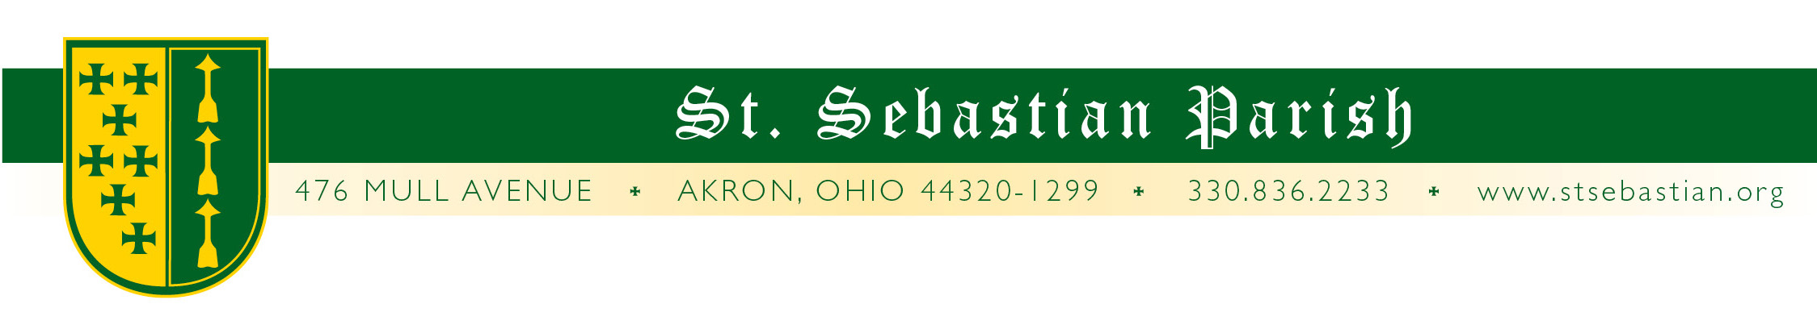
Angelus Letter
17 September 2020
Thursday of the Twenty-Fourth Week in Ordinary Time
St. Robert Bellarmine

Dear Parish Family,

WHAT YOU NEED TO KNOW FOR THIS WEEKEND

Friday Mass 8AM* Fr. Valencheck
Confessions 4 to 5PM*
Saturday Mass 8AM* Fr. Valencheck
Confessions 9:30 to 10AM*
Vigil Mass 4:30** Fr. Simone
Sunday Mass 9AM*† Fr. Fr. G. David Bline
Mass 11AM* Fr. Valencheck
Mass 1PM* Fr. Pascal OSB

* Masks are required.

**At the 4:30 Mass, with permission from the diocese, there is an absolute requirement for masks to be worn.

† Introduction of the St. Padre Pio relic and blessing of the chapel.

PADRE PIO

PLEASE NOTE: Somewhere I wrote incorrectly that the Mass at which we would introduce the St. Padre Pio relic would be at the 11AM Mass. This is incorrect. It will be at the 9AM Mass this Sunday, September 20th. Fr. G. David Bline will be the main celebrant.

Also, at this Mass we will have a blessing of the chapel that was the former church library and originally the baptistery. It will now house the relic of St. Padre Pio and become a seasonal shrine and confessional when needed (as it has been for COVID). This space, which also houses some of the parish artwork when not on seasonal display, is also a place for your prayers and reflection.

I would like to thank everyone who helped bring this day to fruition. By special note, I would like to thank Bob Branham who volunteered to make the shelf on which the relic will sit, although I do not think we will be able to have it installed in time for Sunday.

For information on relics, please see my bulletin letter. There is also some information for those who are interested in learning more here: https://www.catholic.com/tract/relics

OUR NEW BISHOP

As of 2:30PM this past Tuesday we have a bishop! Now you will begin hearing the prayer for him in the Mass, “and Edward our bishop.” Bishop Edward Malesic is the 12th ordinary of our 170+ year old Diocese of Cleveland. If you are interested in seeing his installation, it can be found on the diocesan website dioceseofcleveland.org. Please keep him in your prayers.

DEACON TERRY PEACOCK UPDATE

Deacon Terry’s surgery went well and he says, “Thanks! I couldn’t have made it without the love and prayers from the parish community. I look forward to seeing all in the near future - especially our young people. You are in my prayers. As always - I love you all.” Please keep him in your prayers.

MISC.

ORGAN: We have the floor organ that we have had in storage for a spell for which we need to find a new home. We thought we had one but it fell through. If you know of a place in need of a nice but small pipe organ, please let me know.

EUCHARISTIC DEVOTIONS: I am so happy to report that I was wrong. I had some concerns that, while thinking it was absolutely vital that we move ahead with our Devotions, attendance during this time might be a bit challenging. I was wrong. Very wrong. In fact, this might have been one of our better years as far as participation (and not that it has ever been poor!) Fr. Anthony and I didn’t plan a big closing thinking that it would be a more modest event, but there again, we miscalculated your devotion to Our Lord. (This is why I love being here.) So, we had a healthy candlelight procession with the Eucharist and the icon of St. Sebastian around our St. Sebastian campus.

Thank you to everyone who participated in any way, and all those who helped out. Of particular note is our sacristan, Karen Spangler, the Knights of Columbus, seminarian Charlie Bulger, and the team of others who did all of the behind-the-scenes work for this three-day event. God bless!

PETER MAURIN CENTER: St. Sebastian Parish will be manning the kitchen and serving meals at The Peter Maurin Center this weekend for our community in need. Our parish provides the meal at the center the 3rd Sunday of each month. Thank you to the volunteers who continue to serve the less fortunate in our community. May God bless each of you and the work that you do.

PRAYERS FOR THE SICK

Please keep all of our sick and distressed in your prayers:

The Caufield Family, Regina Buhalak, Paul Carr, Rita Cummings, Anthony D’Attoma, Carolyn Jeske, Kimberly Jesser, Kathy Johnson, Chuck Kastor, Stan Kennedy, Jean Labate, Don Matis, Betty O’Hara, Pamela Oliver, Terry Peacock, Keith Pecek, Sue Prexta, Frank and Nancy Ropchock, Nancy Rosche, John Schultz, Cory Schulz, Marilyn Spallino and Marie White.

God bless you,

Fr. Valencheck.
St. Sebastian, pray for us.
St. Mary, pray for us.
St. Robert Bellarmine, pray for us.

